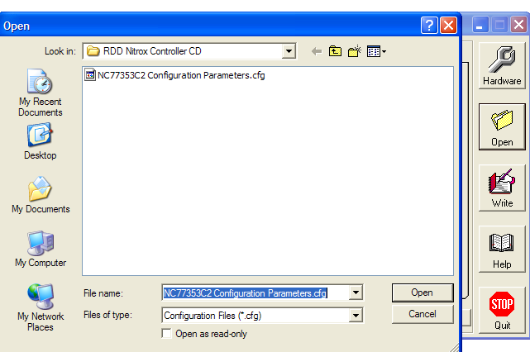

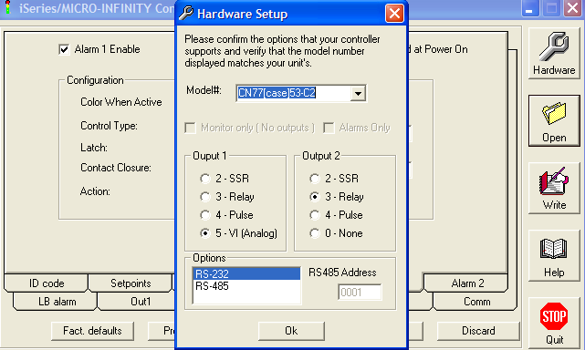

Make sure you select CN77[case] from the Model# drop down window. Depending on the software version you are using, the default value is missing a “]” and won’t work properly. This bug was fixed in the version 1.8 interface software.

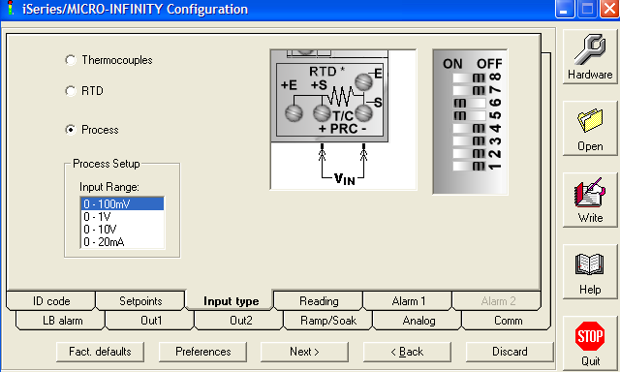

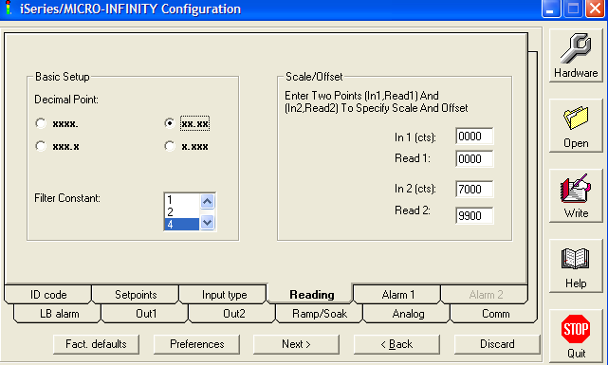

You will change the value of In 2(cts) to calibrate the controller. Decreasing the value of In 2(cts) will cause the controller to indicate a higher oxygen percentage. The value of In 2(cts) should decrease over the life of the oxygen sensor.

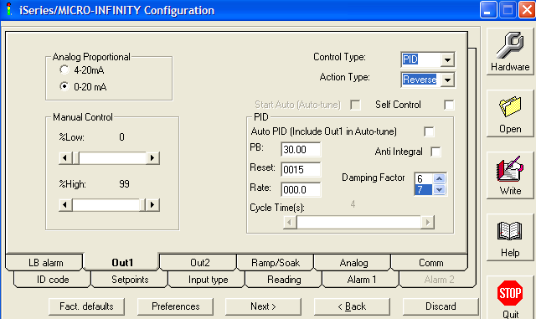

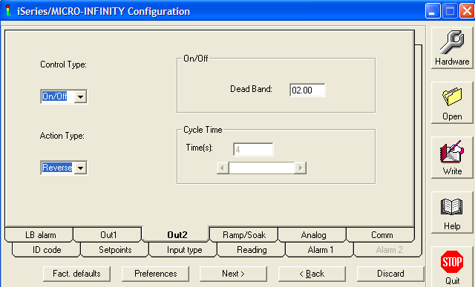

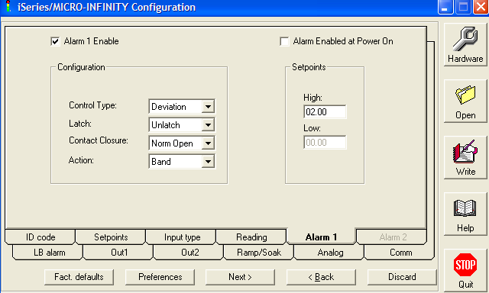

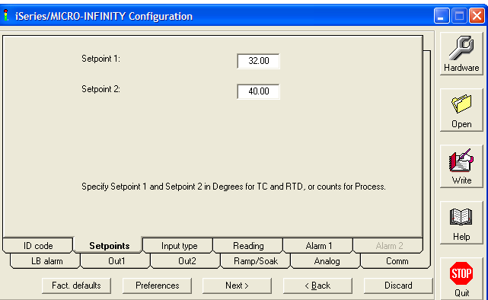
Setpoint 1 represents the oxygen percentage that the controller will maintain when blending Nitrox.

Setpoint 2 should be set to 40%. If the oxygen percentage should climb to 40%, a relay inside the controller will open and de-energize the oxygen control valve.

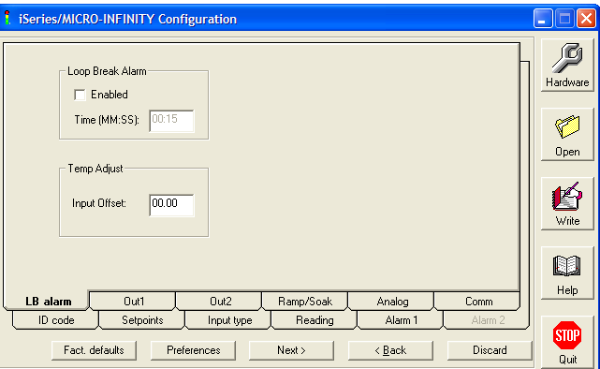

The Nitrox Controller does not use the Loop Break Alarm function.

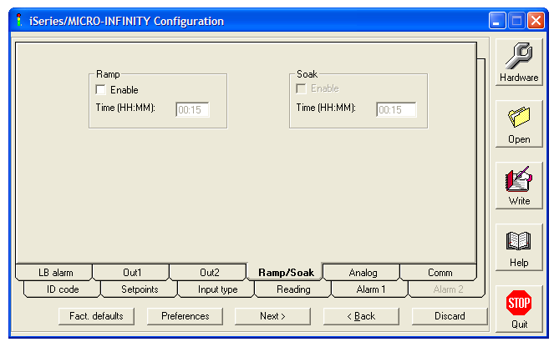
The Nitrox Controller does not use the Ramp or Soak function.

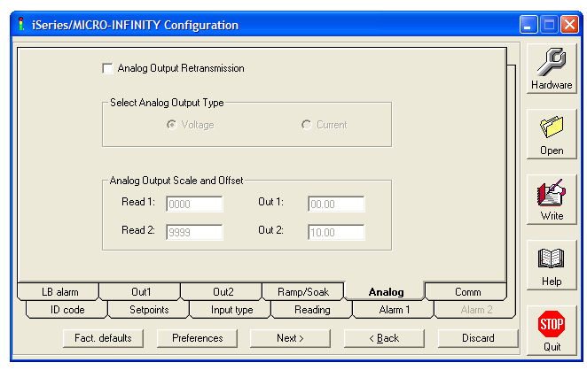
The Nitrox Controller does not use the Analog Output Retransmission function.
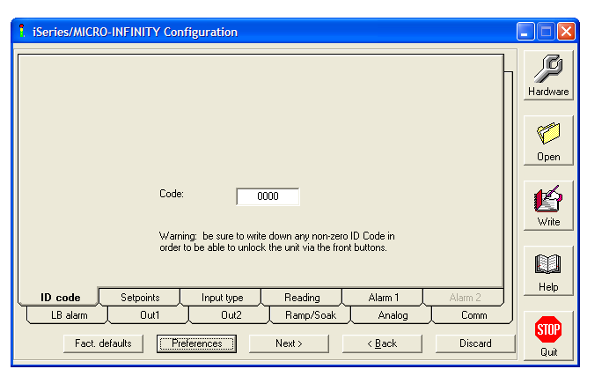

Putting a number in ID Code will lock the front panel buttons such that you will not be able to change any of the controller settings unless you enter the correct code. The ID code has no effect on programming the Controller via this interface program.

