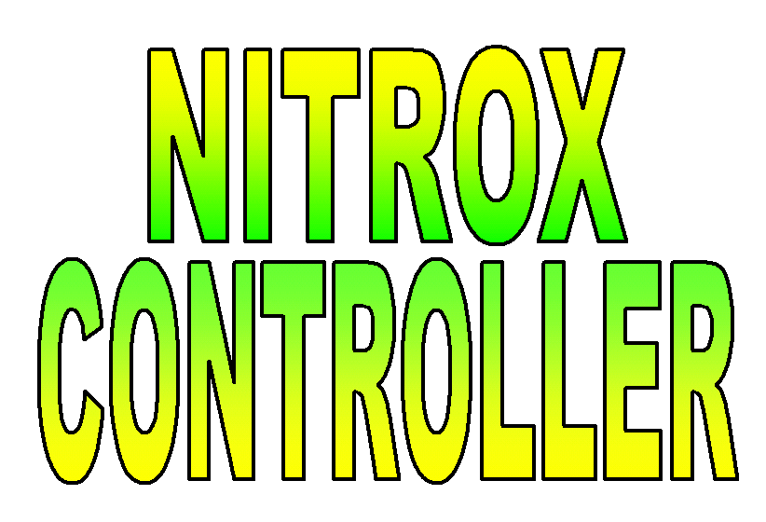
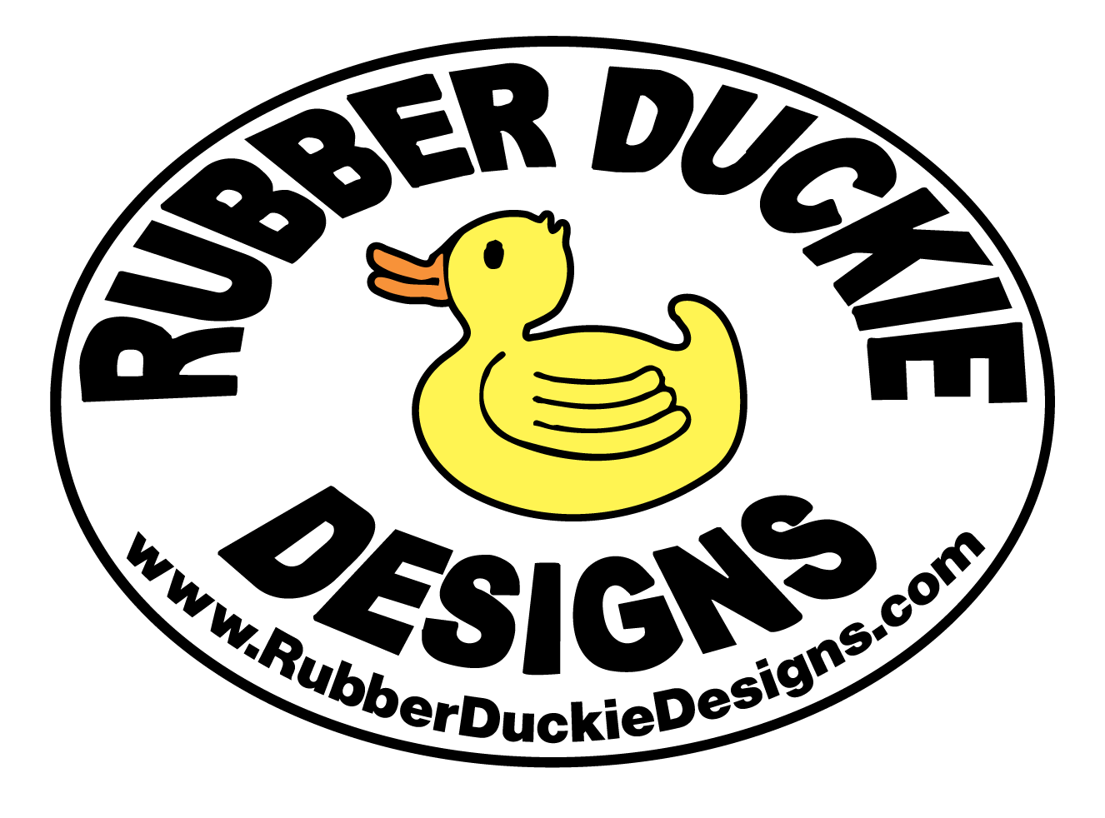

Rubber Duckie Designs Nitrox Controller

O₂ Calibration

Normal Use.

During normal use, you will calibrate the Nitrox Controller by adjusting the oxygen calibration knob on the front of the controller, much like you would a hand held oxygen analyzer. Initially calibrate the controller to indicate the desired value (20.9% oxygen in dry air, slightly less in humid air) when the air compressor is running and you are not blending Nitrox. After you have been blending Nitrox for a few minutes, and the system has purged the filters and hoses, you can refine this calibration setting by correcting the controller to indicate the same as the oxygen analyzer at the output of the air compressor.

Oxygen Sensor Performance.

The output of the oxygen sensor is a voltage that is nearly linearly proportional to the partial pressure of oxygen in the mixture being measured. The output of the sensor is 0 miliVolts (mV) for an oxygen concentration of 0%. In the presence of 100% oxygen, at one atmosphere, the output of the sensor, when new, is in the range of 55-75 mV.

The oxygen sensor does not read oxygen concentration directly but responds to partial pressure of oxygen. As the partial pressure of oxygen increases, the rate of reaction inside the sensor goes up, and the output voltage from the sensor increases. Changes in ambient pressure will change the reading on the analyzer without actually changing the concentration or percentage of oxygen. Through the calibration process (turning the blue knob on the Nitrox Controller), you relate a partial pressure of oxygen, and the associated sensor output voltage to an oxygen percentage. An increase in ambient pressure will increase the partial pressure of oxygen and result in an apparent increase in oxygen concentration. It is normal for the sensor to show substantial variation in oxygen concentration over the course of a day due to changes in ambient pressure, temperature and humidity.

Moisture in the air dilutes the other gases present (mostly Nitrogen and Oxygen). If the Nitrox Controller is calibrated to indicate that there is 20.9% oxygen when in fact there is only 20.4% oxygen (due to the dilution effect of water present in the air), the end result is that the Nitrox mix will contain less oxygen than desired. Your compressor will remove any water vapor in the air as part of the normal compression process and concentrate the remaining gasses. This is why moist air containing 20.4% Oxygen goes into your compressor but dry air containing 20.9% Oxygen will come out. This dilution due to humidity and subsequent concentration due to the compressor introduces errors that should be accounted for so that you get the most accurate Nitrox mix possible.

You will most likely want to calibrate your controller to indicate about 20.8% Oxygen when your compressor is running and you are compressing regular air. As humidity levels increase, you will want to calibrate your controller to indicate a lower Oxygen concentration. You can download the Humidity Spreadsheet at http://www.rubberduckiedesigns.com/Documents/Nitrox Controller Downloads/Humidity Spreadsheet.xls which will recommend a value to calibrate your Nitrox Controller to, based on your atmospheric conditions, so that you will get a more accurate Nitrox mix.

Temperature, or rather a change in temperature, also effects the calibration of the oxygen sensor. As the temperature of the oxygen sensor increases, the rate of the chemical reaction inside the sensor increase and the output voltage of the sensor goes up (apparent increase of oxygen), for no actual change in oxygen partial pressure. During the Nitrox blending process, oxygen goes from high pressure inside the oxygen cylinder to lower pressure at the outlet of the oxygen regulator. This expansion results in a substantial amount of cooling as may be evidenced by condensation or frost on the regulator, metering valve, and solenoid operated valve. This cold oxygen cools the gases going through the Nitrox Stik and subsequently cools the oxygen sensor. The oxygen sensor was initially calibrated at one temperature, and is now operating at a lower temperature. The oxygen analyzer now indicates a lower concentration of oxygen than actually present due to this change in temperature. When the gas at the outlet of the air compressor is analyzed, it contains higher levels of oxygen than expected. For continuous gas blending systems associated with large air compressors (large flow rate of oxygen) this mechanism of cooling may dominate, and to get a correct mix at the outlet of the air compressor, the Nitrox Controller may need to be initially calibrated to indicate 20.9% or greater.

An oxygen analyzer measuring the gas at the outlet of the air compressor will be the most accurate sensor in your system as variations in humidity, temperature, and pressure are minimized and the sensor will only be responding to changes in oxygen percentage. This oxygen analyzer measuring the compressor outlet can be used to provide a calibration reference for the oxygen sensor at the Nitrox Stik and will help you to achieve the most accurate Nitrox mix.

Background.

The oxygen sensor that was provided with the Nitrox Controller may need to be recalibrated as chemicals inside the sensor are consumed and the range of the calibration knob is no longer sufficient to properly calibrate the controller. You may also need to recalibrate a replacement sensor if its output differs dramatically from the previous one. The sensor is rated at 9,000 100% oxygen hours and should last about 4-5 years under normal use.

The output of the oxygen sensor is a voltage that is nearly linearly proportional to the partial pressure of oxygen in the mixture being measured. The output of the sensor is 0 miliVolts (mV) for an oxygen concentration of 0%. In the presence of 100% oxygen, at one atmosphere, the output of the sensor, when new, is in the range of 55-75 mV. You will recalibrate the oxygen sensor by entering a value that represents the output of the sensor in the presence of 100% oxygen, multiplied by 100 (i.e. 60mVx100=6000).

The controller can be programmed in two ways. It can be programmed directly from the front panel display or it can be programmed from your personal computer with the interface software, configuration file, and serial connection.

Calibrating the Controller from a Personal Computer.

1. Ensure that the interface software is installed on your computer. A copy of the software and configuration file was provided with your controller. You can download any software you might need and check for periodic updates at http://www.rubberduckiedesigns.com/NitroxControllerSupport.htm.

2. Connect your personal computer to the serial port on the Nitrox Controller.

3. Open the Newport Electronics I-series and MICRO-INFINITY Config program.

4. Open the Controller configuration file. A Hardware Setup window should pop up. Select “CN77[CASE]” under the model drop down menu. Under output 1, select “VI(Analog)”. Under output 2 select “Relay”. Under options, select “RS-232”. The model # should display “CN77[case]53-C2”.

5. Click the Reading tab. Verify the following:
The Decimal Point: “xx.xx”.
The Filter Constant: “4”.
In 1(cts) : “0000”
Read 1: “0000”
Read 2: “9900”

6. The value you input for In 2(cts) will calibrate the Controller to read the correct oxygen concentration. The controller initially comes programmed with In 2(cts) to a value of about 6000 (The controller initially comes calibrated and every O₂ sensor is slightly different). Putting in a value slightly greater than this (i.e. 6200) will make the controller indicate a lower value of oxygen concentration. Putting in a value slightly lower than this (i.e. 5800) will make the controller indicate a higher oxygen concentration.

7. Click on the “Write” tab on the right side of the interface software window. Click on “Serial Port” to write the new configuration settings to your controller. Once the controller completes downloading the settings, it will reset itself, and go into the “Run” mode. Press the Enter button on the controller front panel twice to shift the controller into the “Standby” mode.

8. Repeat steps 4, 5, and 6 as necessary to fine-tune your controller to indicate the correct Oxygen concentration.

9. Save the configuration file. Click on the “Write” tab on the right side of the interface software window and then on “File” to save the configuration file to your computer’s hard drive.

Calibrating the Controller from the Front Panel Display.

1. Press the Menu button until the display shows “rdG CnFG” in the window. Press the Enter button.

2. Press the Menu button until the display shows “InPt SCOF” in the window. Press the Enter button.

3. The values for “In 1” and “rd 1” should be 0000.

4. Press the Enter button until the display shows “In 2” in the window.

5. Pressing the ⇒/Min will change the display so that the next digit to the right will then blink. Press the ⇑/Max button to initially change the digit to “0”, continue pressing the ⇑/Max button until the desired value is entered. Then press the Enter button to enter this value as the new value.

6. The value you input for “In 2” will calibrate the Controller to read the correct oxygen concentration. The controller initially comes programmed with “In 2” to a value of about 6000 (The controller initially comes calibrated and every O₂ sensor is slightly different). Putting in a value slightly greater than this (i.e. 6200) will make the controller indicate a lower value of oxygen concentration. Putting in a value slightly lower than this (i.e. 5800) will make the controller indicate a higher oxygen concentration.

7. Verify that the value for “rd 2” is 9900. If this value has changed, change it back to 9900. Then press the Enter button to enter this value as the new value.

8. Press the ⇒/Min button until the controller resets itself and goes into the “run” mode. Press the Enter button on the controller front panel twice to shift the controller into the “Standby” mode.

9. Repeat steps 1 through 8 as necessary to fine-tune your controller to indicate the correct Oxygen concentration.

