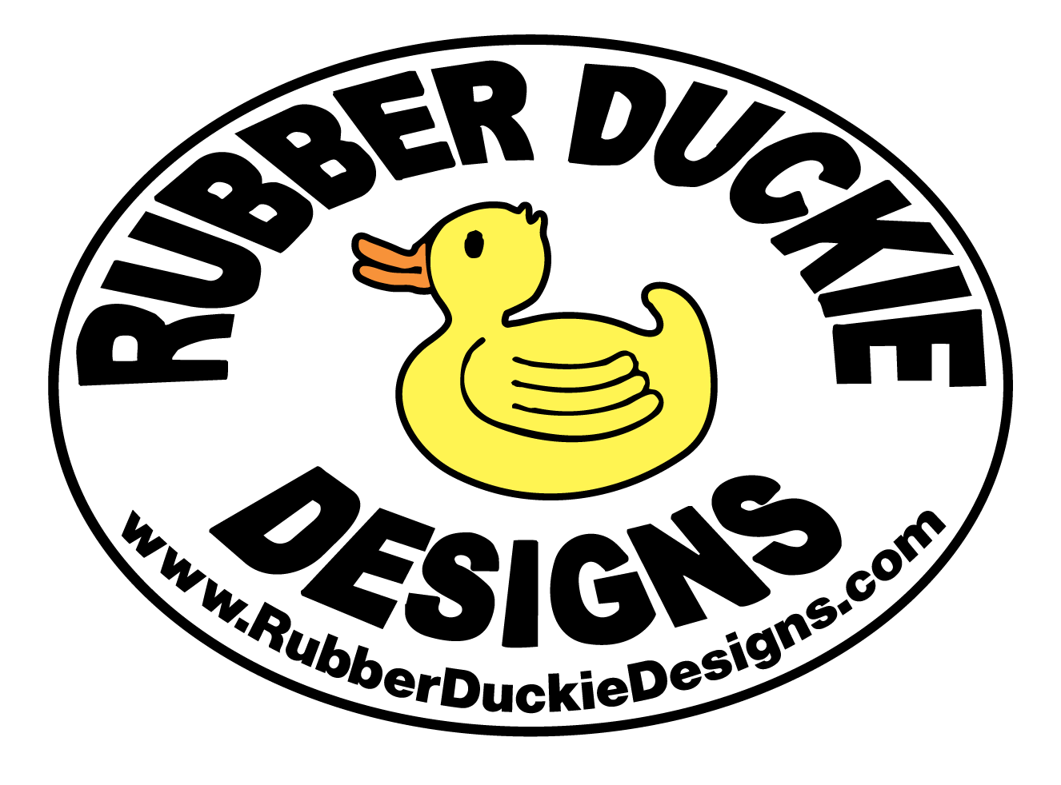 | 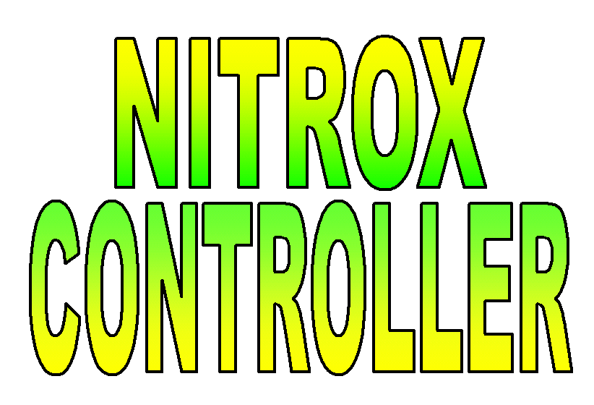

Rubber Duckie Designs Nitrox Controller

Operating Instructions

Startup

Calibrate the O₂ Analyzer at the output of the air compressor with dry SCUBA air.

Verify that the supply valve on the O₂ tank is open, and that the regulator reads a sufficient O₂ pressure to blend the desired O₂ concentration.

While the compressor is running, adjust the O₂ calibration knob to calibrate the Nitrox Controller to the desired value.

To Place the unit into Run, press the Enter button. The controller will open the solenoid-operated valve to maintain the O₂ concentration at the indicated set point. It will take about 30 seconds to stabilize at this value.

After the system has been running for a few minutes and Nitrox has purged the air system filters and hoses, check the air compressor output O₂ analyzer. Adjust the Nitrox Controller O₂ calibration knob so that the Nitrox Controller upper display line also indicates this value. The Controller will adjust the solenoid-operated valve to return the O₂ concentration to the indicated set point.

Shutdown

To stop blending Nitrox, place the controller into Standby and shut the O₂ supply valve on the oxygen tank.

To place the controller into Standby, press the Enter button twice.

Note: When not blending Nitrox, the unit should be placed into Standby, otherwise an alarm condition will exist and the buzzer will “buzz.”

Changing the O₂ Blend

To change the oxygen blend (e.g. from 32% to 36% O₂), press the Menu button once until the green SP1 (Set Point 1) on the left side of the display is blinking. The first digit of the set point display will then blink. Pressing the ⇒/Min will change the display so that the next digit to the right will then blink. Press the ⇑/Max button to initially change the digit to “0”, continue pressing the ⇑/Max button until the desired value is entered. Then press the Enter button to enter this value as the new set point.

Alarm Conditions

There is an alarm buzzer on the controller to notify the operator of any anomalous condition. If the controller is unable to maintain the Nitrox blend within 2% of the set point, the alarm buzzer will sound. Place the controller into Standby to silence the buzzer and shut the O₂ supply valve on top of the O₂ tank.

